Feature Selection Problem

- Introduction
In the field of data mining, one fundamental task is prediction, which involves determining unknown values by leveraging related data.
Taking house price prediction as example, each house is associated with features like area, floor, housing age, and the number of rooms. Additionally, each house is linked to a label, which in this case is the price. As depicted in Figure 1, with this type of data, we can train a model to forecast the house price. Subsequently, this model can be employed to predict the prices of other houses for which the prices are unknown.
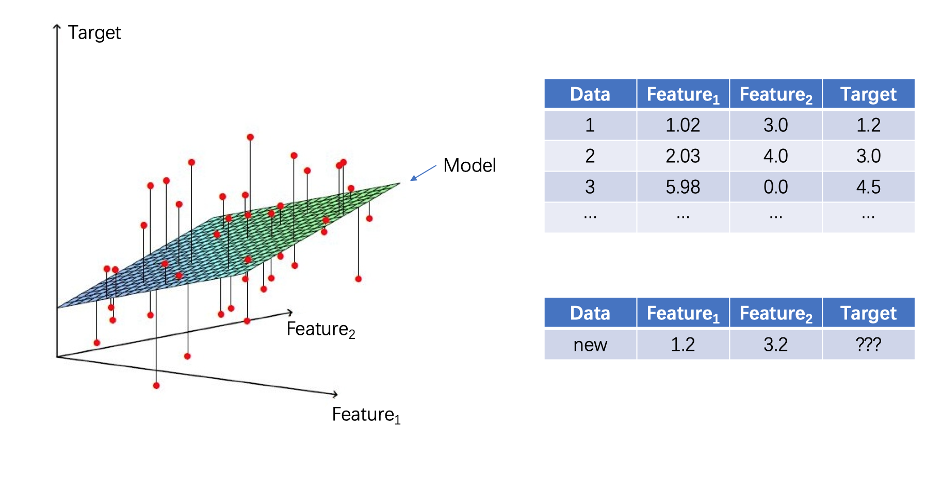
Figure 1. The prediction task

Nonetheless, in numerous industrial scenarios, not all features contribute positively to model training. Superfluous features not only escalate computational complexity but can also misguide the model, leading to subpar model performance. Feature engineering is the method of enhancing the quality of the features that empower your model. Feature selection, a fundamental feature engineering technique, strives to identify and choose the features that enhance your model’s performance.
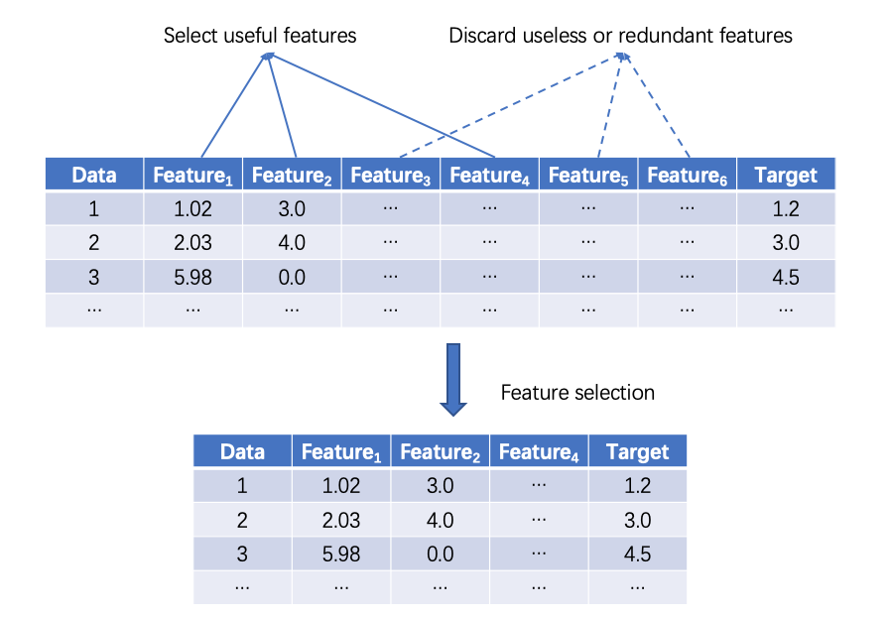
Figure 2. Feature selection

- Purpose: Feature Selection for industrial dataset using GA/ACO/PSO
Here we have an industrial dataset with 2888 records. The first 50 columns can be used to predict the last column. You can try models such as Linear Regression or Support Vector Regression ... After training your model, you should evaluate it using a test set or cross-validation.
Unsurprisingly, not all the 50 columns contribute to improving the model’s performance. Consequently, you need to select a subset of them as the input of your model. Note that it is almost impossible to try all the subsets of the features, because the number of them is 2⁵⁰. Therefore, you need to apply GA/ACO/PSO to solve the feature selection problem.

  - Write a program to train and evaluate a regression model. You don’t need to implement the regression model by yourself. (Python + scikit-learn is highly recommended)
  - Design GA/ACO/PSO algorithms for feature selection.
  - Implement your algorithms and improve them by trying different ideas.

